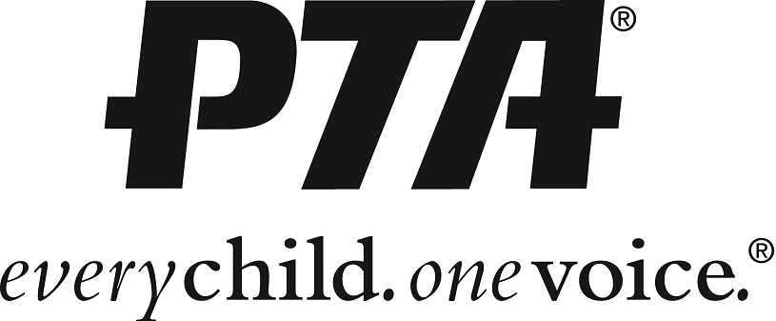

Slate of Officers for the Pleasant View PTA’s consideration
for the 2022/2023 school year:

President | Megan Barone
Vice President of School Relations | Karyn Green
Vice President of Student Programs | Amy Featherstone
Vice President of Fundraising | Susan Smith
Secretary | Mindy Gassman
Treasurer | Erin Onions

